GUIDELINES FOR PREPARING A PAPER FOR THE 4th INTERNATIONAL CONFERENCE ON ADVANCED CONCEPTS ON MECHANICAL ENGINEERING, ACME 2010, IASI, ROMANIA
BY

JOHN SMITH*, GHEORGHE POPESCU**

Abstract: This is an example of an ACME 2010 proceedings paper, as you should submit it. Use one column format, with the title and author information centered on the first page. Dimensions for the paper are specified in this text.

Key words: four to eight key words
1. Introduction
Buletinul Institutului Politehnic din Iasi will only publish original scientific papers. The paper will be printed from the submitted file prepared by you. You should send the file in Word format, to make possible small changes of your manuscript, if necessary. Please adhere to the style guidelines below to allow us to maintain uniformity in the final printed copy of the Proceedings. If you have any questions, please contact us.
2. General instructions
You should submit up to six (6) A4-size pages (par number of pages) for a regular paper and up to sixteen (16) pages for an invited paper. The pages will be printed exactly as received, without any reduction.
All text should be written in English, French or Germany. English is the official language of the conference.
2.1 Layout specifications
All printed material, including text, figures, and tables, must be kept within a print area of 125 mm wide by 200 mm high. Do not write anything outside this area. The top and bottom margins must be 48.5 mm, left and right margins should be 42.5 mm. All text must be single spaced, in the specified one-column format.
Please, do not paginate your paper. The final page numbers will be assigned and printed later by the publisher.
2.2 Title page
The paper title should begin 93 mm from the top edge of the first page, centered, completely capitalized, and in Times (Times New Roman) font, boldface type, in 12-point size.
2.2.1 Author’s name(s)
The author's name(s) appear below the title, centered, completely capitalized, in Times New Roman font, boldface type, in 10-point size. Author's affiliation(s) will appear at the end of the paper (just before the references), as you will see in this guide.
2.2.2 Abstract
Each paper should contain an abstract of about 100-150 words and 4-8 key words that appear at the beginning of the first page.
2.3 Type style and fonts
All text should be in Times New Roman, and the main text should have a font-size of 11 points.
Paragraphs in each section should be indented as these paragraphs demonstrate.
3. Headings
Major headings, subheadings and sub-subheadings should appear in 11-point bold face lower case, centered, with one blank line before and one blank line after. Use a period (“.”) after the heading number, not a colon.

4. Other style guidelines
4.1 Abbreviations
Define abbreviations and acronyms the first time they are used in the text, for example like this: “This paper discusses finite impulse response (FIR) filters…”.
4.2 Equations
The equations must be centered with respect to the page. Number equations consecutively with equation numbers in parentheses flush with the left margin of the column, as in (1). Define all the symbols in your equations before or immediately after the equation. Here is an example. The frequency response of an Nth-order FIR filter can be expressed as
(1) $H(e^{jω})=\sum_{n=0}^{N}{h(n)e^{−jω\text{nT}}}$
where h(n), for n = 0, 1, 2, ..., N, are the coefficients of the FIR filter, ω = 2πf is the angular frequency, and T is the sampling interval.
Use the same letter size in equations as in the normal text. Note that a longer dash (–) rather than a hyphen (-) should be used for a minus sign, if possible.
4.3 Illustrations
Illustrations must appear within the designated margins, and must be part of the submitted paper. All illustrations must be captioned and numbered consecutively, in the order they first appear in the text, using Arabic numerals. Remember to use the term ``Figure N'' in both the caption and when it is referred in the main text, e.g. Figure 1.

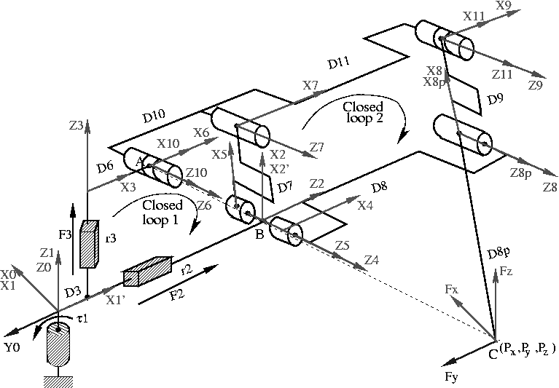

Fig. 1 - Figure example
4.4 Tables
All tables must be captioned and numbered consecutively, in the order they first appear in the text, using Arabic numerals. Remember to use the term ``Table N'' in both the caption and when it is referred in the main text.

Table 1 - Table example

j | a(j)
1 | 0 | ⁰ | 0˚ | 0 | 0˚ | 0 |  | 0
2 | 1 | 1 | -90˚ | 0 | 90˚ | 0 | 90˚
3 | 1 | 1 | 0˚ | 0 | 0˚ |  | 0
4 | 2 | 0 | 0˚ | 0 | -90˚ | 0 |  | 0
5 | 2 | 0 | 0˚ | 0 | -90˚ | 0 |  | 0
6 | 3 | 0 | 0˚ | 0 | 90˚ |  |  | 0
7 | 5 | 0 | 0˚ | 0 | 0˚ |  |  | 0
8 | 4 | 0 | 0˚ | 0 | 0˚ |  |  | 0
9 | 8 | 0 | 0˚ | 0 | 0˚ |  |  | 0
10 | 7 | 0 | 0˚ | 0 | 0˚ |  | 0˚ | 0
11 | 7 | 0 | 0˚ | 0 | 0˚ |  | 0˚ | 0
8p | 8 | 0 | 0˚ | 0 | 0˚ |  | 0˚ | 0

4.5 References
References must appear as you see in this example.
5. Conclusion
Thank you for your prospective contribution. We look forward to seeing you at the ACME 2010 conference!

Received May 30th 2010 * Royal Military Academy of Brussels
Department of Applied Mechanics
e-mail:
** “Gh Asachi” Technical University of Iassy
Theory of Mechanisms and Robotics Dep.
e-mail:

R E F E R E N C E S

1. A c h e r o y M., B a u d o i n Y. and P i e t t e M., Belgian Project on Humanitarian Demining (HUDEM), First International Symposium CLAWAR, Brussels, 26-28 Nov. 1998.
2. H a b u m u r e m y i J.C., Adaptive Neuro-Fuzzy Control for a Walking Robot with 6 Pantograph-based Legs, PhD Thesis, Free University of Brussels, 2004.
3. R a n d a l l M.J., P i p e A.G., An Intelligent Control Architecture and Its Application to Walking Robots, Proceedings of International Workshop on Advanced Robotics and Intelligent Machines, Salford, UK, 1997, ISSN 1363-2698.
4. S c i a v i c c o L. and S i c i l i a n o B., Modeling and Control of Robot Manipulators, Springer-Verlag Edition, ISBN 1-85233-221-2,1996.
5. T o d d D. J., Walking Machines: an Introduction to Legged Robots, Kogan Page Ltd, 1985.
6. W e t t e r g r e e n D., Robotic Walking in Natural Terrain: Gait Planning and Behavior-based Control for Statically-Stable Walking Robots, PhD Thesis, Carnegie Mellon University, 1995.
TITLUL ÎN LIMBA ROMÂNĂ(Times New Roman - 10 points)
(Rezumat) (Times New Roman - 10 points)

